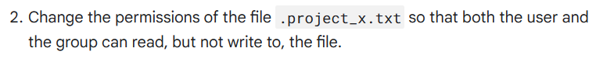

**Activity completed Using Linux bash shell**



Explanation :

Here I have used the chmod command to change file permissions for user, group and other. The -rwx means it’s a regular file which is indicated using (-), r means read access, w mean write access and x means executable access. -rwxrwxrwx means the user falls in the first rwx then the next rwx is for the group and the third is others to change the permission we need to use + or – signs along with chmod to grant or take away the access for the user, group, or other which is done by the following command chmod u-w, g+r, o+x .project_x.txt here the u-x means taking away write permissions from user, g+r means giving read permission to group and o+x means giving executable permission to others.